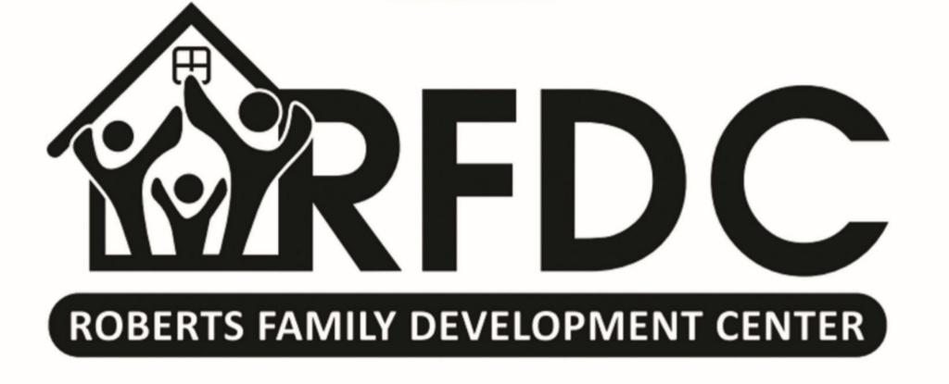
Roberts Family Development Center
PARENT COMMITMENT & PLEDGE

I, _______________________________, promise to make a positive contribution to the Roberts Family Development Center using my time and finances. I promise to take necessary actions that will ensure my child’s success in school and in life. My household will commit to making my child’s academic career a priority. I will also participate in the following while my child attends the Roberts Family Development Center after-school program.
Please choose an option below:
- Current RFDC Parent Commitment:
- I will make a monthly contribution to the Roberts Family Development Center of $25 per child every month.
- I will attend our monthly parents/family meeting.
- I will make sure my child attends the after-school program daily.
or
- NEW RFDC Parent Commitment: (childcare/daycare/drop-in center)
- I will make a monthly contribution to the Roberts Family Development Center of $350 per child every month.
- No monthly parent/family meeting requirement
- You will receive a monthly invoice to be paid on or before the 10th of every month.

Parent/Guardian’s Signature ___________________________ Date __________

